I.E.S. Mariana Pineda. Geography and History

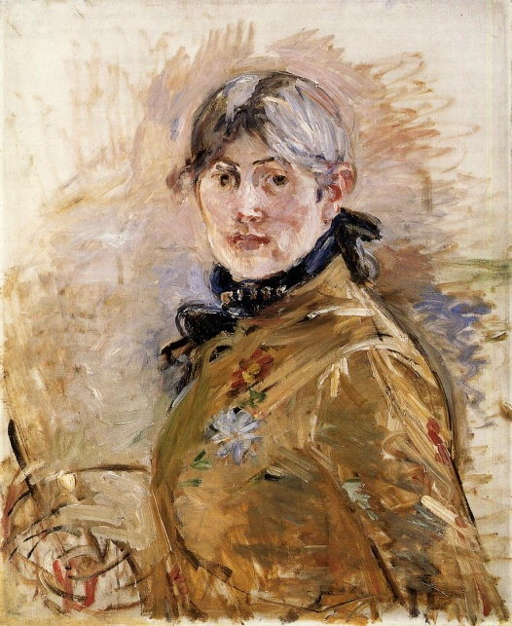

BERTHE MORISOT: AN EQUAL AMONG PAINTERS

Key words: exhibition, follower, palette, plain air (outdoor painting), auction, canvas, achieve.

Answer the following questions:
- In how many Impressionist exhibitions did Berthe Morisot take part?
- Despite producing more than 860 paintings, what did her death certificate say?
- What were supposed to be the feminine qualities of her paintings?
- What places couldn’t she visit in order to preserve her respectability?
- What did she write in one of her notebooks?
- At what age did she die? What was the cause of her death?
- What price was paid for one of her works in an auction in 2013?

Fill in the gaps of the following sentences related to women artists:
- Berthe Morisot was an ____________ and a member of the circle of painters in Paris who became known as the ______________.
- Sofonisba Anguissola worked more than 15 years at Philippe II ___________. She painted many ___________ of the king and his family.
- ___________ and bronze were the main materials that Camille Claudel used in her ___________.
- The Museo Reina Sofía in Madrid has the most important ____________ of Maruja Mallo’s works.
- Frida Kahlo was a ____________ painter. She ___________ Diego Rivera, also an artist, known for his murals.

