I.E.S. Mariana Pineda. Geography and History

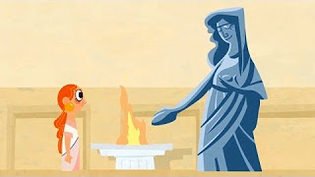

FOUR SISTERS IN ANCIENT ROME

- What is the name of the four sisters, Lucius Domitus Ahenobarbus’ daughters, who are the main characters of the story?

a) Livia b) Domitia c) Petronila
2. Did their brothers have longer or shorter names?

- Why is it difficult to know what women did in Ancient Rome and throughout History?

- Men wrote history.
- Women didn’t do anything relevant.
- Women wrote history

- Did the Roman women have more or less freedom than the Greek ones? Why?

- What were the gifts that Philato gave to Domitia I, his future wife? Underline the correct words:
engagement ring, flowers, earrings, horse, necklaces, pendants, chocolates, dog, dress.

- What did Domitia III draw in the graffitis she made on one of the columns of the Porticus of Livia, the first wife of the emperor Augustus? Answer and define the word you choose.

- Politicians
- Soldiers
- Gladiators

- Who was Domitia I? Why was she considered a successful woman?

- How did the master control his slaves?

- By terror and violence. He punished them.
- By politeness and affection.
- By paying them a high salary.

