I.E.S. Mariana Pineda. Geography and History

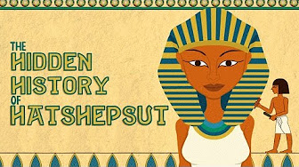

THE HIDDEN HISTORY OF HATSHEPSUT

- When did the pharaoh Hatshepsut rule Egypt?

- What is the meaning of the term “damnation of memory”?

- Although it was legal for a woman to be a monarch in Ancient Egypt, why did it disturb many people? Choose two reasons.
a) She was not qualified for this position.
b) A belief in tradition, order and justice.
c) She wasn’t the legitimate heir to the throne.

- Match the following terms with its definition:
a) Pharaoh a person appointed to administer a state because the monarch is a minor or is absent
b) Regent a person who inherits or has a right of inheritance to the king’s throne
c) Heir the most powerful person in Ancient Egypt, similar to a king
- Why is Hatshepsut considered a good pharaoh? Choose two reasons.
- She was a great builder.
- She conquered many territories, such as Syria and India.
- She had strong religious connections.
- She transformed the agriculture and stock-farming.

- Say if the following sentences are true or false. If they are false you should correct them.
- At the beginning, Hatshepsut was the regent of his own son, Thutmose III. Probably, he erased Hatshepsut’s images because she stole his throne. _____
- Hatshepsut was violently attacked during her life. Someone tried to kill her. ______
- Hatshepsut’s memory was erased because her successors wanted to forget that a woman ruled Egypt. _____
- The pharaoh was supposed to be the earthly embodiment of the goddess Isis. _____

