I.E.S. Mariana Pineda. Geography and History

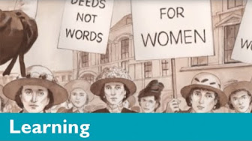
STORIES FROM PARLIAMENT: VOTES FOR WOMEN

Key words: suffragette, march, protest, party, meeting, crowd, law, court, imprisonment, cell, stink

Answer the following questions:
1. When and where does the story take place? Why are the suffragettes doing a march?

2. Write three reasons why suffragettes demand the legal right of women to vote:

3. How long does Constance Lytton spend in prison? What confession does she make at the end of the video?

Tick the suffragettes’ demands seen in the video:
Votes for women Equal salary for women
Equal education Deeds not words
Women should be law makers Financial and legal independence
Divorce and free contraception Do us justice

Say if the following sentences are true or false. Remember that if they are false you should correct them:
- Emmeline Pankhurst, the leader of the suffragettes, is a lady. She belongs to a family of the ruling class. ______
- At the beginning of the 20th century important post were barred to women in all professions. _____
- Constance Lytton is afraid of being imprisoned a second time. As a result, she decides to abandon the Women Suffrage Movement. ______
- At the Houses of Parliament a police man tells Constance Lytton to go home and take care of her children. ______

